BIOTECH MARKET RESEARCH $IDYA | Ep. 942
Ideaya Biosciences

IDEAYA Biosciences ($IDYA) has become a catalyst-driven trade into the randomized Phase 2/3 OptimUM-02 topline PFS readout for darovasertib + crizotinib in 1L HLA-A2-negative metastatic uveal melanoma, expected late March 2026. Investors are framing the event as a binary validation of the single-arm survival signal and, more broadly, as proof that PKC inhibition plus cMET blockade can meaningfully shift frontline outcomes in a historically refractory disease. The stock only structurally re-rates if the dataset shows clear and clinically meaningful PFS separation versus investigator’s choice, with a persuasive hazard ratio and clean safety profile that supports regulatory positioning for accelerated approval. Investors will overweight absolute median PFS delta versus control, hazard ratio stability across key baseline characteristics, event maturity, and whether discontinuation rates or dose reductions erode real-world combinability. If the PFS delta compresses toward historical controls or toxicity complicates exposure, the narrative shifts from “first targeted backbone in UM” to “single-arm inflation,” compressing franchise expectations and pushing valuation back toward longer-duration optionality in DLL3 and MTAP programs. Options are pricing +/- 90% volatility.
Every Monday we are out with public biotech research, profiling biotech companies with near term catalysts. This will focus primarily on the major market moving biotech events such as data readouts from the major scientific conferences as well as potential regulatory approvals.
We will not offer specific trading advice (and we do not hold any publicly traded biotech equity), but rather flag emerging events that will likely materially drive stock prices (sometimes +/-100% in either direction).
Be sure to SUBSCRIBE to not miss.

HOW TO PLAY BIOTECH APPROVAL/DATA READOUTS ANNOUNCEMENTS
While biotech equities will move on news of announcement, often if there is high conviction in a positive read, a large run up ahead of the news will occur and the actual event turns into a sell the news event. Sometimes, investors wait for the actual event to make a long/short decision. And obviously if the news is disappointing (more often than not) the stock will tank.
This is not financial advice so you will have to make your own call on how to best play these events. Our aim is simply to flag catalysts with high projected volatility.
🚨 ALERT: Darovasertib + Crizotinib Phase 2/3 PFS Readout (Q1 2026)
📅 TIMING: Q12026
📈 IMPLIED MOVE: ~±90%
BACKGROUND:
About the company:
IDEAYA is a precision medicine oncology company committed to the discovery, development, and commercialization of transformative therapies for cancer. Our approach integrates expertise in small-molecule drug discovery, structural biology and bioinformatics with robust internal capabilities in identifying and validating translational biomarkers to develop tailored, potentially first-in-class targeted therapies aligned to the genetic drivers of disease. We have built a deep pipeline of product candidates focused on synthetic lethality and antibody-drug conjugates, or ADCs, for molecularly defined solid tumor indications. Our mission is to bring forth the next wave of precision oncology therapies that are more selective, more effective, and deeply personalized with the goal of altering the course of disease and improving clinical outcomes for patients with cancer. IDEAYA's corporate presentation is available on its website:
https://ir.ideayabio.com/
PORTFOLIO:
The company’s can be seen below:

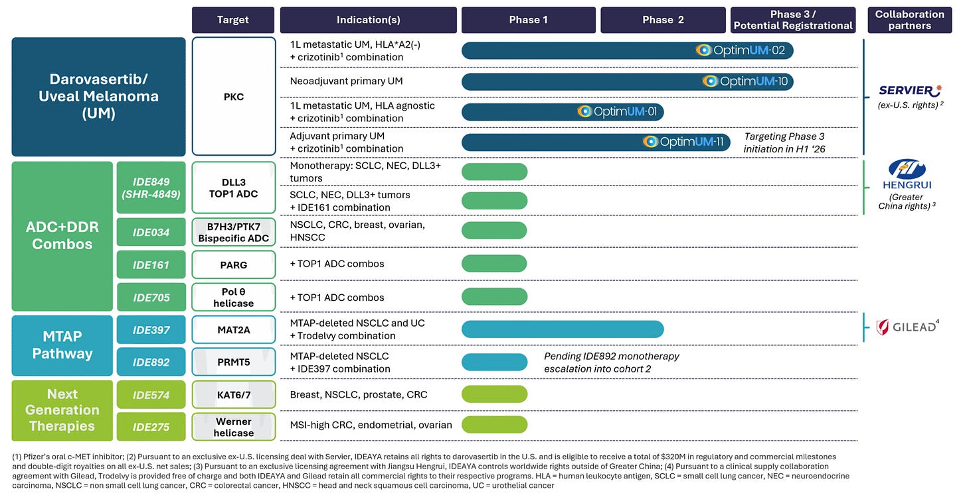

What Biotech Investors Need to Know
Anchor expectations to hazard ratio magnitude and event maturity in first-line HLA-A2-negative metastatic uveal melanoma, not single-arm cross-trial comparisons. The catalyst is the randomized Phase 2/3 OptimUM-02 topline PFS readout for darovasertib + crizotinib, expected late March 2026. The key question is whether the combination delivers clean and clinically meaningful PFS separation versus investigator’s choice, sufficient to support a credible accelerated approval pathway.
Bulls want a statistically persuasive hazard ratio with a clear median PFS delta, no early KM curve convergence, and durability signals that support the prior 7.0-month single-arm PFS narrative. They will look for consistency across baseline characteristics, manageable discontinuation rates, and no emergent toxicity that undermines dose intensity. A clean win validates PKC plus cMET inhibition as a frontline backbone in uveal melanoma and materially de-risks the franchise.
Bears will focus on classic failure modes in small, rare-disease randomized trials: marginal hazard ratio, control arm outperforming historical benchmarks, curve flattening without separation, or safety signals that drive dose reductions and exposure erosion. If the PFS benefit appears modest or fragile, the narrative shifts from “first targeted standard in UM” to “single-arm inflation,” compressing peak sales assumptions and pushing valuation back toward longer-duration pipeline optionality rather than near-term commercialization.

Confidence in mechanism
Confidence in mechanism should be discounted, not assumed, until randomized PFS separation in OptimUM-02 demonstrates that PKC inhibition plus cMET blockade meaningfully alters frontline metastatic uveal melanoma biology rather than transiently suppressing signaling.
- Driver ubiquity may be overstated. While >95% of UM harbors activating GNAQ/11 mutations driving PKC overactivation, pathway prevalence does not guarantee pathway dependency. UM biology involves MAPK, YAP/TAZ, and parallel survival networks. PKC inhibition may suppress one axis while leaving adaptive escape routes intact.
- Metastatic biology may not be cMET-dominant. The rationale for adding crizotinib centers on HGF-driven liver tropism, but hepatic metastasis is multifactorial. If cMET signaling is contributory rather than central, incremental blockade may not translate into durable resistance control.
- Single-arm OS inflates mechanistic confidence. The 21.1-month median OS in a 41-patient dataset is hypothesis-generating, not proof of durable driver suppression. Selection bias, favorable baseline risk, or supportive care improvements can exaggerate apparent biology-driven survival shifts. Only randomized hazard ratios remove that ambiguity.
- PFS separation does not equal durable pathway control. A statistically persuasive hazard ratio can mask early KM convergence, front-loaded benefit without tail durability, or informative censoring in a rare-disease setting. If curves compress over time, the mechanism reads as temporary tumor control rather than structural resistance suppression.
- Combination confounds attribution. Any benefit observed in OptimUM-02 is inseparable between PKC and cMET inhibition. Without monotherapy superiority data in the same setting, mechanistic credit remains shared and potentially overstated.
- Adaptive resistance risk remains high. Chronic PKC inhibition may induce feedback activation of compensatory pathways. If resistance emerges rapidly, frontline durability compresses and the mechanistic ceiling narrows.
- Rare-disease scale can obscure liabilities. Even a 437-patient randomized study may not surface low-frequency hepatotoxicity, cardiovascular imbalance, or cumulative tolerability signals that become relevant in adjuvant or long-duration use.
- Regulatory framing can redefine mechanism. Even with statistical PFS success, lack of OS maturity, subgroup fragility, or safety-driven label constraints can reposition the drug as incremental rather than transformative, limiting commercial translation of the biology thesis.
What upgrades confidence: clear and durable PFS separation versus investigator’s choice, stable hazard ratios over time without curve convergence, consistent benefit across baseline characteristics, maintained dose intensity without exposure erosion, and regulatory alignment that the effect reflects durable disease control rather than transient signaling suppression.

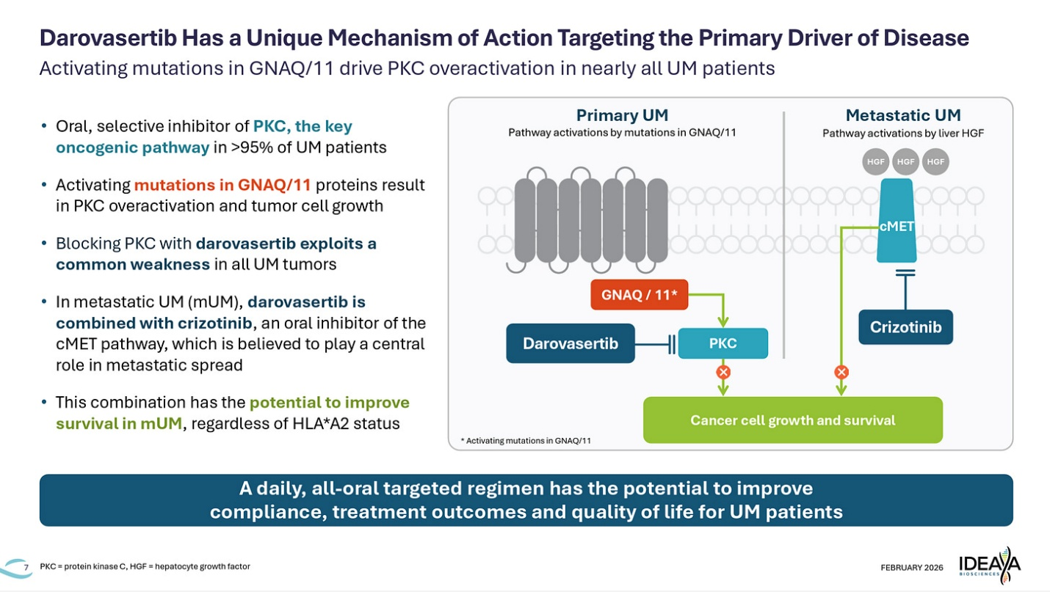

PK, exposure, and distribution
PK is central to whether darovasertib’s PKC inhibition meaningfully suppresses oncogenic signaling in uveal melanoma, and here the data are directionally supportive but not fully de-risked. The claim is sustained PKC pathway suppression in a disease driven by GNAQ/11 mutations, combined with cMET inhibition to limit metastatic signaling. That requires durable systemic exposure at levels sufficient for continuous pathway control without cumulative toxicity that forces dose compromise.
- Exposure appears manageable on paper. The combination regimen of darovasertib 300 mg BID plus crizotinib 200 mg BID has demonstrated a mean treatment duration of ~10 months in metastatic UM, with reported tolerability supporting continued dosing in the single-arm dataset. That directionally suggests exposure can be maintained long enough to generate clinical responses.
- PK does not automatically equal durable pathway suppression. Plasma exposure does not confirm sustained intratumoral PKC inhibition or downstream signaling blockade over time. If randomized KM curves in OptimUM-02 converge late, PK adequacy becomes a central question: was exposure biologically insufficient, or is PKC inhibition simply not sufficient to control adaptive resistance?
- Exposure–response relationships remain underdeveloped publicly. There is limited disclosed modeling correlating darovasertib exposure levels with PFS durability, depth of response, or OS benefit. Without clear exposure–response linkage, it remains unclear whether the therapeutic window is wide or whether benefit sits near a narrower exposure threshold vulnerable to variability.
- Combination exposure complicates attribution. BID PKC inhibition layered with BID cMET inhibition increases the risk of overlapping tolerability signals. If hepatic, GI, or cardiovascular adverse events emerge at scale, dose reductions could erode effective pathway suppression. Early datasets are encouraging but small; Phase 3 scale is the stress test.
- Distribution in metastatic UM introduces additional uncertainty. Liver-dominant disease may present variable drug penetration dynamics. Plasma PK does not guarantee uniform distribution within hepatic metastases, particularly in heavily pretreated or fibrotic tissue environments.
- Chronic exposure risk is different from short-duration oncology therapy. If darovasertib ultimately moves into adjuvant or neoadjuvant settings, cumulative safety becomes more relevant. Even modest low-grade toxicities can affect adherence and long-term exposure maintenance.
What upgrades confidence: durable PFS separation without dose-intensity drift in the randomized setting, low discontinuation and reduction rates at Phase 3 scale, and exposure–response analyses demonstrating consistent benefit across baseline risk groups. Current PK data are supportive of feasibility but do not fully eliminate mechanistic uncertainty until randomized durability is confirmed.

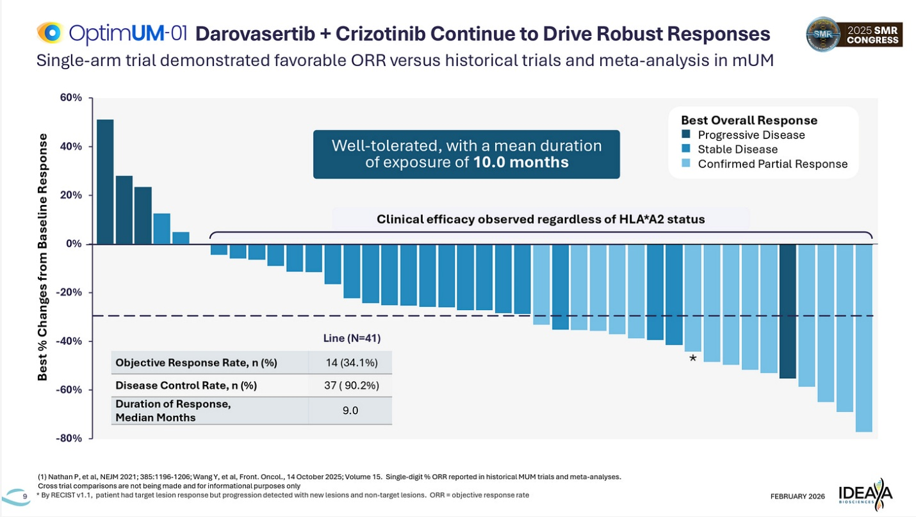

PD read-through
PD read-through into the OptimUM-02 catalyst is a durability and resistance-control test, not a question of whether PKC signaling can be inhibited acutely. The topline randomized PFS will determine whether PKC plus cMET suppression meaningfully disrupts downstream proliferative and metastatic signaling in frontline metastatic uveal melanoma or whether pathway inhibition plateaus once adaptive biology engages.
- Acute pathway inhibition is not the debate. PKC sits directly downstream of GNAQ/11 mutations, and preclinical data support target engagement. The open question is whether that engagement translates into durable downstream suppression of MAPK, YAP/TAZ, and other compensatory pathways in human tumors over time.
- PD durability is the unresolved risk. If Kaplan-Meier curves separate early but converge later, it implies incomplete downstream pathway control or rapid emergence of bypass signaling. In frontline disease, sustained hazard ratio stability is the mechanistic bar, not early median PFS optics.
- Combination biology muddies attribution. Crizotinib’s cMET inhibition may influence metastatic signaling independent of PKC blockade. If benefit appears modest, it becomes unclear whether PKC suppression lacks depth or whether cMET contribution is insufficient. The PD ceiling may reflect structural biology limits rather than drug execution.
- Liver-dominant disease is the PD stress test. With ~90% of mUM metastasizing to the liver, effective tumor control requires sustained suppression within a unique hepatic microenvironment. HGF-driven signaling and stromal interactions may blunt durable pathway inhibition despite adequate systemic exposure.
- Subgroup consistency will inform PD credibility. If hazard ratios fluctuate meaningfully across baseline risk strata, LDH levels, or metastatic burden, it raises questions about uniform downstream pathway control. A broadly effective mechanism should not rely on narrow clinical subsets.
- Dose intensity intersects with PD. If toxicity forces reductions, effective signaling suppression may drift below therapeutic threshold. Exposure-maintained PD is required for durability; exposure erosion undermines mechanistic confidence.
- Scale is where PD narratives break. Rare-disease trials are vulnerable to event clustering, regional variability, or assessment timing differences that distort perceived pathway control. Only stable separation over time validates that PD effects translate into structural resistance delay rather than transient pathway pressure.
Overall, the catalyst will not re-litigate whether PKC can be inhibited. The PD question is whether sustained PKC plus cMET suppression materially delays resistance emergence in frontline metastatic uveal melanoma. Confidence upgrades only if hazard ratios remain stable over time, curves avoid late convergence, and safety supports uninterrupted exposure, signaling that PD effects translate into durable tumor control rather than temporary signaling suppression.

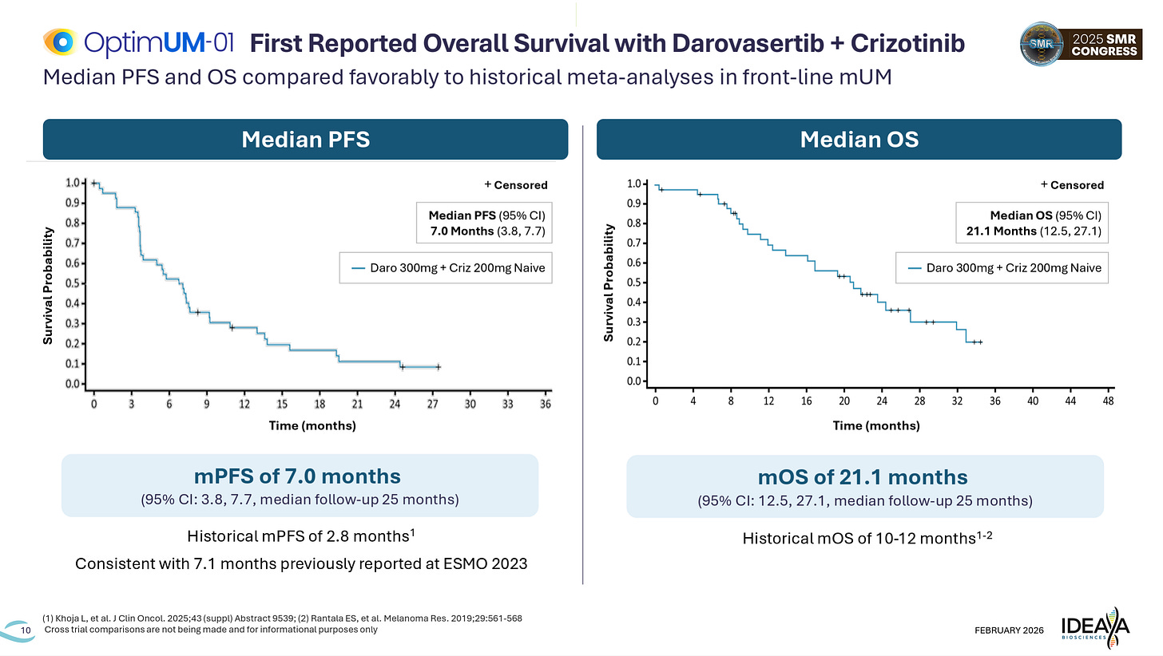

Clinical Trial Design
The OptimUM-02 program is sensible but not low-risk, because the same design choices that make a registrational rare-oncology trial feasible (PFS primary endpoint for potential accelerated approval, open-label execution, multi-region enrollment, heterogeneous investigator’s choice control, and a combination regimen) are the ones that can blur attribution and compress upside if the topline is merely incremental.
- Two interpretability layers, two different failure modes. First is the statistical outcome (does BICR PFS separate cleanly on the pre-specified event count); second is the narrative outcome (is the separation durable, clinically meaningful in absolute terms, and robust enough that critics cannot explain it away via control-arm mix, imbalances, or operational noise). The N is respectable for uveal melanoma, but rare-disease heterogeneity still creates multiple ways to “win” technically while losing the story.
- Primary endpoint is PFS per BICR for a potential accelerated approval filing, so “practice change” must be earned, not assumed. A hazard ratio can be statistically persuasive yet still feel modest if median delta is small, curves converge late, or censoring patterns raise eyebrows. In a setting where patients and physicians are used to rapid progression, the bar for enthusiasm is not p-value, it’s durable separation that looks like real disease control.
- Investigator’s choice control is both practical and a narrative liability. The control arm spans pembrolizumab, ipi/nivo, or dacarbazine. That heterogeneity is convenient for enrollment and ethics, but it creates interpretation risk: if control performs unusually well, the delta compresses; if control performs poorly, skeptics argue the win is “made” by a soft comparator mix. Either way, the debate shifts from biology to trial plumbing.
- Open-label conduct adds subtle bias channels even with BICR. BICR helps on the primary endpoint, but open-label trials still carry operational variance in scan timing, dropouts, dose management, and subsequent therapy patterns. If the topline is borderline, critics will look for regions or sites where the signal concentrates and whether that is exportable.
- Combination dependence is the structural vulnerability. Darovasertib + crizotinib is the unit of analysis, which means attribution is inseparable. If tolerability forces reductions in either drug, the incremental effect can disappear into noise. The entire design is a dose-intensity stress test because the hypothesis is sustained dual-pathway suppression, not a short burst of response.
- AA-on-PFS is high-consequence in a disease where OS narrative matters. The trial is explicitly positioned to use PFS for a potential U.S. accelerated approval and OS for full approval. That creates a mismatch risk: a “PFS win” that looks modest or fragile can still be filing-enabling, yet commercially and mechanistically underwhelming. And if OS is slower to mature or diluted by subsequent therapies, the full-approval story can lag.
Key questions this design needs to deliver
Does the topline show a hazard ratio and absolute PFS delta that feels clearly additive versus a heterogeneous investigator’s choice control, not just statistically positive?
Is the benefit durable over time (no early separation followed by late convergence) and coherent across baseline risk strata, metastatic burden, and other clinically relevant characteristics?
Does safety and dose intensity support sustained full-dose combination therapy without exposure erosion that would undermine the incremental effect?
What are the risks to doing so
Control-arm heterogeneity can compress or distort perceived delta depending on mix and regional practice patterns.
Open-label operational variance (scan timing, dropouts, subsequent therapy) can create apparent late convergence or unstable hazard ratios that critics will weaponize.
Dose reductions or discontinuations in either agent can erode effective pathway suppression and turn a real biological effect into a noisy clinical signal.
A modest PFS win can be filing-enabling but narrative-negative, limiting label enthusiasm and commercial adoption even if technically successful.
Is this a high risk or aggressive design?
It’s not reckless, but it is high-consequence and moderately aggressive. The design is constructed to win on PFS with BICR support, yet the program’s value inflects only if the effect is clearly durable and clean enough that control-arm and operational critiques do not dominate the conversation.

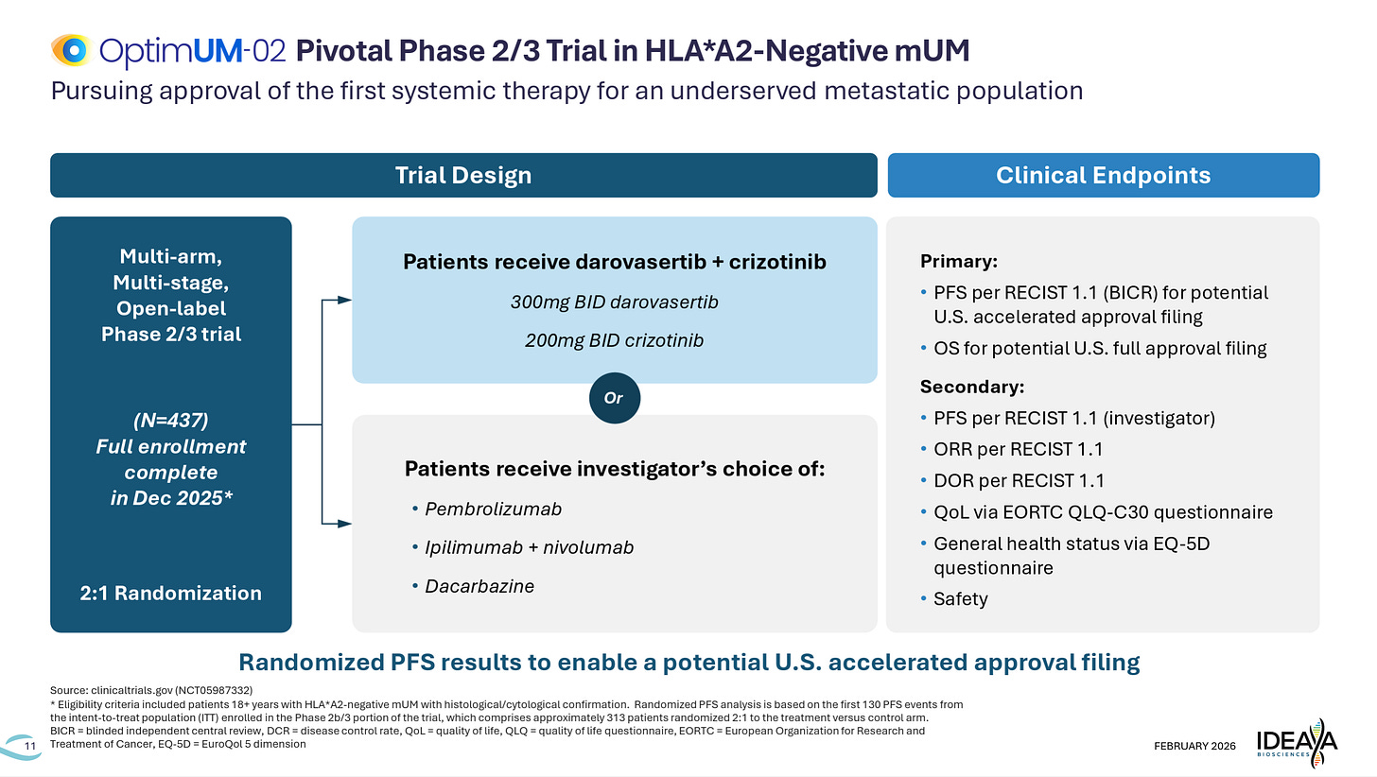

Competition Check

Baseline standard of care sets a magnitude and durability bar, not a statistical bar.
In first-line HLA-A2-negative metastatic uveal melanoma, the relevant comparators are investigator’s choice regimens including pembrolizumab, ipilimumab + nivolumab, and dacarbazine. Historical median PFS has been short, and OS historically ~10–12 months, but control-arm performance in OptimUM-02 defines the true competitive benchmark. The bar is therefore clear and durable additive benefit over contemporary real-world control, not cross-trial comparisons to small historical datasets.

OptimUM-02 is the real benchmark into the catalyst.
The randomized Phase 2/3 PFS readout will determine whether PKC inhibition plus cMET blockade meaningfully extends disease control versus investigator’s choice without dose-intensity erosion. The question is not whether darovasertib can induce responses, that is already shown in single-arm data, but whether the combination structurally delays progression in a randomized setting. If the hazard ratio is modest or curves converge late, the competitive narrative compresses quickly.

The catalyst test is structural differentiation, not statistical superiority alone.
Rare oncology trials can be technically positive yet commercially muted. What the market will focus on is absolute median PFS delta, tail durability, and hazard ratio stability over time, not just p-values. If benefit feels incremental relative to control, enthusiasm compresses toward niche positioning. If separation is clean and durable, it resets expectations for PKC-targeted therapy as a frontline backbone.

Control-arm performance defines competitive optics.
If investigator’s choice underperforms historical benchmarks, critics will discount the win as control-driven. If control performs better than expected, the delta compresses and mechanistic confidence weakens. Either scenario introduces narrative risk. A clean competitive win requires separation that survives scrutiny regardless of control-arm mix.

Other emerging approaches remain background competition.
Tebentafusp remains relevant in HLA-A2-positive disease, and immunotherapy combinations continue to evolve. While not directly competing in the HLA-A2-negative population, broader improvements in systemic therapy raise the durability bar over time. Any signal that PKC inhibition delivers only transient benefit reinforces skepticism around pathway saturation in UM.

Regulatory and commercial credibility are the true moats.
Even with statistically positive PFS, safety, dose intensity, and eventual OS trajectory will shape uptake. If tolerability forces reductions or discontinuations, the incremental benefit becomes harder to justify in a disease with high unmet need but increasing systemic options.
Net: This catalyst is not about whether PKC can be inhibited. It is about whether sustained PKC plus cMET suppression meaningfully extends frontline disease control beyond investigator’s choice. A clean, durable separation expands the mechanistic ceiling. A marginal win or fragile hazard ratio reinforces the view that pathway inhibition alone cannot structurally reshape metastatic uveal melanoma outcomes.

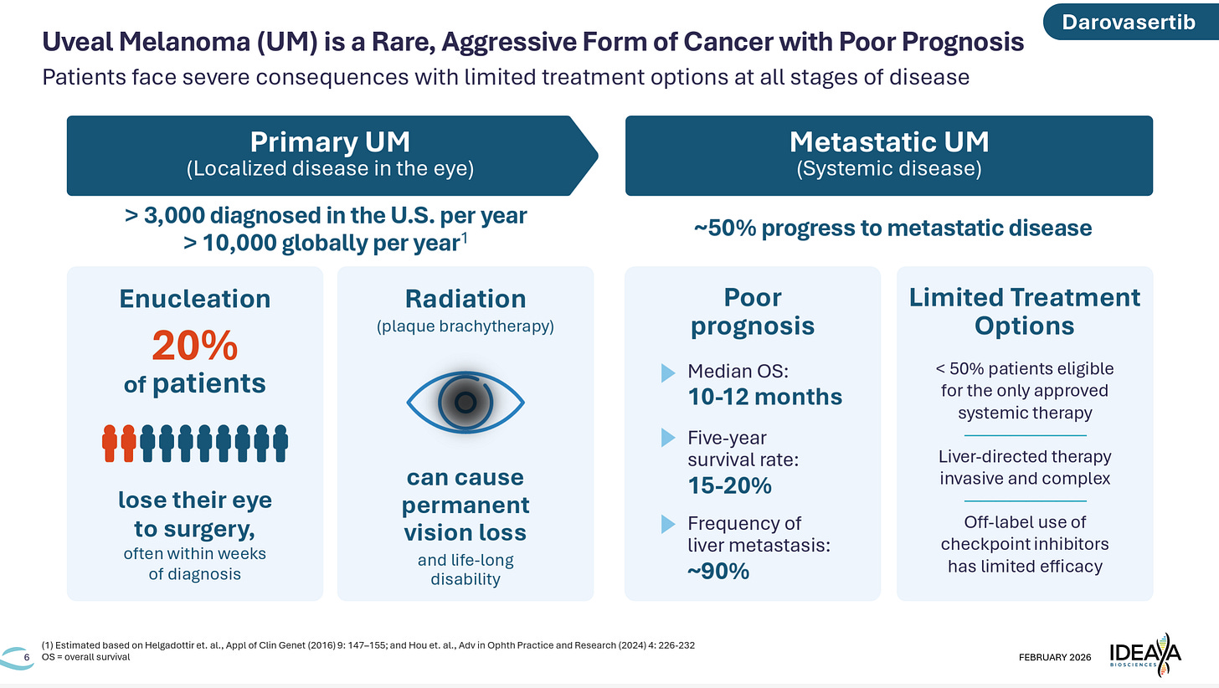

Probability of Success Model

Strong Validation: PKC backbone established, franchise de-risked
Thresholds:
OptimUM-02 demonstrates clear and durable PFS separation versus investigator’s choice, with a hazard ratio that remains stable over time and a clinically meaningful absolute median PFS delta. Curves do not converge late. Benefit appears consistent across baseline risk strata, metastatic burden, and LDH levels. Dose intensity remains intact with manageable discontinuation rates. Safety does not introduce hepatic, cardiovascular, or cumulative liabilities that would threaten sustained exposure. The dataset feels structurally practice-relevant rather than statistically convenient, reinforcing that PKC plus cMET suppression meaningfully extends frontline disease control.
Projected move (re-anchored to options): +35% to +55% (accelerated approval credibility + franchise re-rate)

Modest Validation: statistical win, narrative debated
Thresholds:
PFS is statistically positive, but hazard ratio is modest, curves show late narrowing, or the absolute median PFS delta feels incremental. Benefit appears uneven across baseline characteristics, or control-arm performance muddies attribution. Safety is manageable but introduces exposure erosion via dose reductions or discontinuations. The readout confirms incremental biology but stops short of clearly redefining frontline management.
Projected move (re-anchored to options): +15% to +35% (short squeeze + partial re-rate, followed by digestion)

Equivocal / Mixed: biology confirmed, ceiling questioned
Thresholds:
Topline meets statistical threshold, but absolute PFS delta is small, subgroup dependence is obvious, or operational variance clouds interpretation. Curves separate early but compress over time. Control-arm heterogeneity becomes a focal debate. The narrative shifts to “filing-enabling but commercially narrow,” and enthusiasm for broader PKC platform expansion compresses.
Projected move (re-anchored to options): −15% to −30% (volatility unwind, franchise multiple compression)

Negative: PKC strategy fails to structurally shift frontline outcomes
Thresholds:
Failure to achieve statistically significant PFS improvement, or a win so marginal that clinical relevance is questioned. Evidence of safety creep, dose-intensity drift, or fragile hazard ratios amplifies disappointment. Interpretation shifts to “single-arm inflation,” and confidence in PKC inhibition as a durable backbone collapses.
Projected move (re-anchored to options): −30% to −50% (structural reset toward pipeline optionality)
This catalyst is not about whether PKC can be inhibited. It is about whether sustained PKC plus cMET suppression can materially extend frontline disease control beyond heterogeneous investigator’s choice regimens. The magnitude and durability of separation determine whether the franchise ceiling expands or compresses.

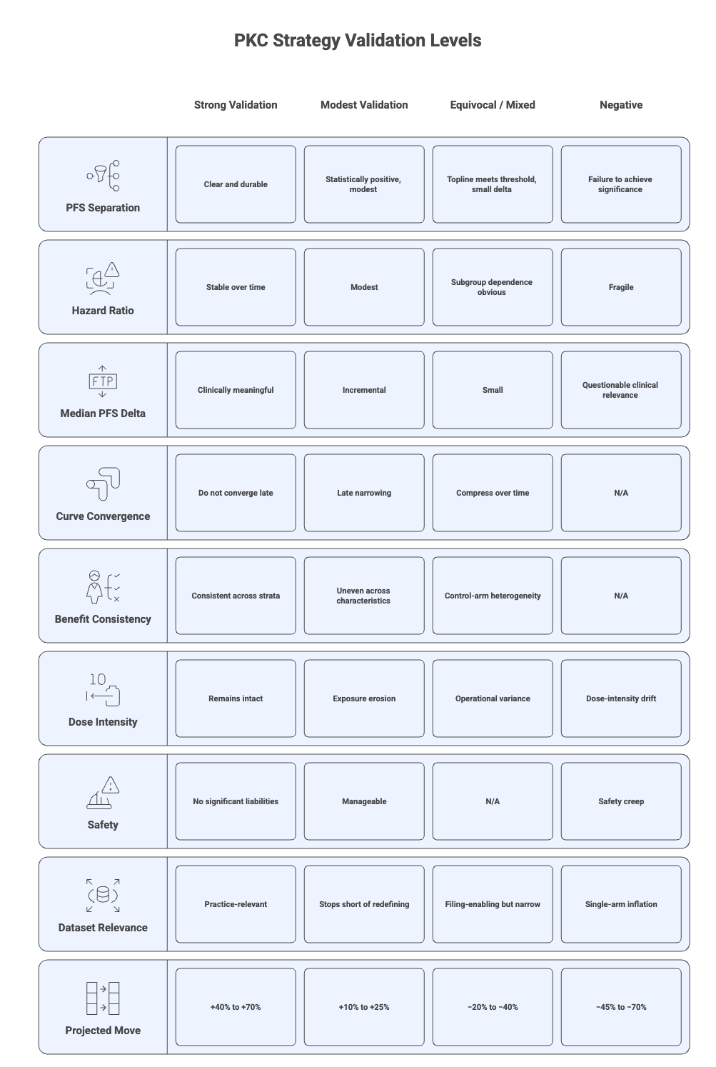

Methodology & Base Assumptions
Program prior (blend of four base rates)
Modality. Oral small-molecule PKC inhibitor combined with cMET inhibition in first-line HLA-A2-negative metastatic uveal melanoma, benchmarked against investigator’s choice in a randomized Phase 2/3 (OptimUM-02 catalyst). Credit: driver mutation present in >95% of UM (GNAQ/11), biologically coherent downstream PKC activation, precedent for PFS-based accelerated approvals in high unmet need oncology. Penalty: pathway redundancy risk, historical difficulty translating targeted pathway inhibition into durable OS in UM, and dependence on dual-agent dose intensity to demonstrate additive biology.
Biology. PKC inhibition intended to suppress GNAQ/11-driven signaling; cMET inhibition layered to mitigate HGF-driven metastatic signaling, particularly in liver-dominant disease. Credit: genetically anchored target, rational combination strategy, early single-arm signal (ORR 34%, mPFS ~7 months, mOS ~21 months). Penalty: adaptive resistance risk via MAPK/YAP and parallel pathways, uncertainty whether cMET is dominant in metastatic biology, and single-arm inflation risk prior to randomized confirmation.
Indication. First-line metastatic uveal melanoma, rare, high unmet need, historically poor outcomes. Credit: low baseline PFS and OS create room for visible improvement; regulatory openness to AA on PFS in orphan oncology. Penalty: small population magnifies variance, control-arm heterogeneity (pembrolizumab, ipi/nivo, dacarbazine) complicates attribution, and OS remains the ultimate durability test.
Sponsor execution & ops. 437-patient randomized, event-driven Phase 2/3 with PFS per BICR primary for potential accelerated approval and OS key secondary. Credit: randomized design removes single-arm ambiguity; BICR strengthens endpoint integrity. Penalty: open-label execution, investigator’s choice control variability, dose-intensity erosion risk in dual-agent regimen, and narrative fragility if curves converge late.
Blended prior. Pre-update program-level PoS that darovasertib + crizotinib delivers clearly additive and durable PFS separation sufficient to support accelerated approval: ~45–50%, reflecting biologically validated driver with real durability and combination risk.

How we update (Bayesian evidence stacking; conservative LRs)
PFS magnitude & durability (core driver).
Clear hazard ratio ≤0.65 with sustained KM separation → LR ~1.4–1.7
Modest HR ~0.75–0.85 or late convergence → LR ~0.6–0.9
Absolute median delta (optics driver).
Δ ≥3–4 months versus control → LR ~1.2–1.4
Δ ≤2 months → LR ~0.7–0.9
Dose intensity & safety sustainability.
Low discontinuation rates; maintained BID exposure → LR ~1.1–1.3
Dose reductions/discontinuations ≥25–30% or hepatic/cardiac creep → LR ~0.6–0.8
Control-arm performance & subgroup coherence.
Consistent HR across baseline strata; control aligns with historical norms → LR ~1.1–1.3
Signal driven by narrow subset or control underperforms → LR ~0.7–0.9
Regulatory & filing credibility.
Effect size clearly AA-supportive with clean BICR alignment → LR ~1.1–1.3
Statistically positive but clinically debated magnitude → LR ~0.7–0.9

Posterior
Upside case (PKC backbone established):
0.48 × 1.5 × 1.3 × 1.2 × 1.2 × 1.2 ≈ 0.65
(Requires durable HR, meaningful absolute delta, and clean dose intensity.)
Middle case (incremental but filing-enabling):
0.48 × 1.2 × 1.0 × 1.0 × 1.0 × 1.0 ≈ 0.55
(Statistically positive; magnitude still debated.)
Downside-lean (single-arm inflation exposed):
0.48 × 0.8 × 0.8 × 0.8 × 0.8 × 0.8 ≈ 0.20–0.25
(Modest HR, control noise, or dose-intensity drift compress narrative.)

Tier calibration
Strong Validation. Durable PFS separation with broad consistency and sustained exposure.
Projected move: +40–70%; accelerated approval path viewed as credible. p₁ → ~60–65%.
Modest Validation. Statistically positive but incremental magnitude or fragile optics.
Projected move: +10–25%. p₁ → ~45–55%.
Equivocal / Mixed. Marginal HR, curve convergence, or attribution debate.
Projected move: −20–40%. p₁ → ~25–35%.
Negative / Failed. No statistically significant PFS benefit or clinically irrelevant delta.
Projected move: −45–70%. p₁ → ≤25%.

Downside tail shifters
Control arm outperforms expectations
Late KM convergence
High discontinuation or dose-reduction rates
Hepatic or cardiovascular safety imbalance
Weak early OS trajectory despite PFS win
What the model penalizes
Durability fragility in a rare disease. The model heavily taxes modest hazard ratios, control-arm ambiguity, and exposure erosion because the single-arm dataset already set a high narrative bar. A marginal PFS win does not validate PKC biology; it simply enables filing.
Bottom line: Pre-update PoS sits just under 50%. It scales meaningfully higher only if OptimUM-02 demonstrates durable, clinically persuasive PFS separation that withstands control-arm and durability scrutiny. Anything short of that shifts probability mass left, consistent with the asymmetric downside embedded in event-driven oncology catalysts.

Technical Considerations (Cash Runway and Short Interest)

Cash Runway
IDEAYA has previously guided that existing cash is projected to fund operations into 2030, inclusive of advancing darovasertib registrational development and pipeline expansion . Burn is elevated given a 437-patient randomized Phase 2/3 trial, parallel neoadjuvant Phase 3 initiation, ADC expansion cohorts, and multiple MTAP combination studies, but there is no immediate balance sheet pressure into the OptimUM-02 PFS catalyst.
The price action implication into the catalyst is important: IDEAYA is not entering this readout with an acute financing overhang. That means the stock is likely to trade as a clean adjudication of PKC + cMET biology rather than as a liquidity event. If OptimUM-02 delivers durable and clinically persuasive PFS separation, valuation can re-rate on accelerated approval credibility and franchise expansion without near-term dilution reflex.
If the readout is mixed or compresses enthusiasm around PKC durability, runway provides insulation against an immediate capital raise. However, that does not protect valuation if the perceived frontline opportunity shrinks materially. In that scenario, the stock likely reprices on franchise ceiling compression rather than solvency concerns.
The real risk is second-order. A marginal PFS win that is filing-enabling but narratively fragile could extend development timelines into OS maturity while burn continues across multiple programs. That scenario increases medium-term financing probability even if there is no near-term need.
Bottom line: runway reduces financing reflex volatility into the OptimUM-02 catalyst, but it does not buffer durability disappointment.

Short Interest
Short interest is elevated but controlled, reflecting conviction skepticism into the OptimUM-02 PFS catalyst rather than technical stress.
With mid-teens percent of float short and mid-single-digit days-to-cover, positioning signals that a meaningful cohort expects durability compression or a modest hazard ratio. This is deliberate fundamental positioning, not a borrow squeeze setup.
Upside requires a clear and durable PFS surprise. If HR ≤0.65 with clean safety, covering can accelerate the move, but it will follow fundamental re-rating, not cause it.
On the downside, positioning is not crowded enough to create air-pocket risk. If the readout is incremental or fragile, shorts can press rather than cover.
Bottom line: this is a referendum setup, not a squeeze setup. The outcome will be driven by hazard ratio magnitude and durability, not positioning mechanics.

WHAT THIS MEANS FOR YOU
Looking at the analysts results and price coverage, those who cover the company rate as a STRONG BUY with 10/10 buy ratings. Keep in mind analyst ratings ALWAYS must be taken with a grain of salt as bearish analysts do not have long careers for obvious reasons.

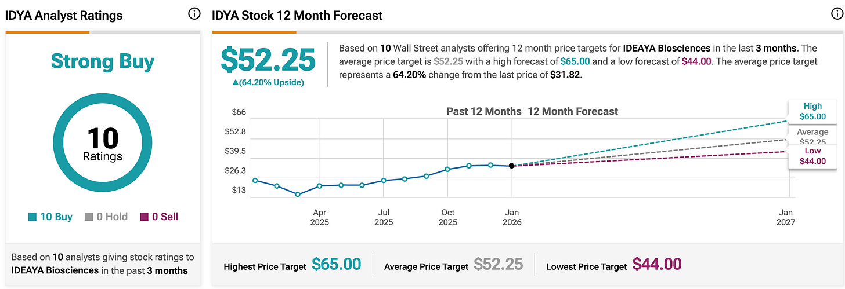

The stock is currently trading at $31.00. The lowest analyst estimate has this one trading at $44. The upside scenario is at $65 - ~2x+ upside with downside potential over the longer timeframe.
If we look at options pricing, and specifically IMPLIED VOLATILITY we can get a sense of the size of the move the traders are projecting. IF you do the math you get about a ~+45% move to the upside, and a -45% move to the downside. That would put the options projected price projections at ~$45 to the upside and ~$17 to the downside. Again, this is for a play on the short term catalyst which is a different timeframe from the 1yr analyst targets shown above.

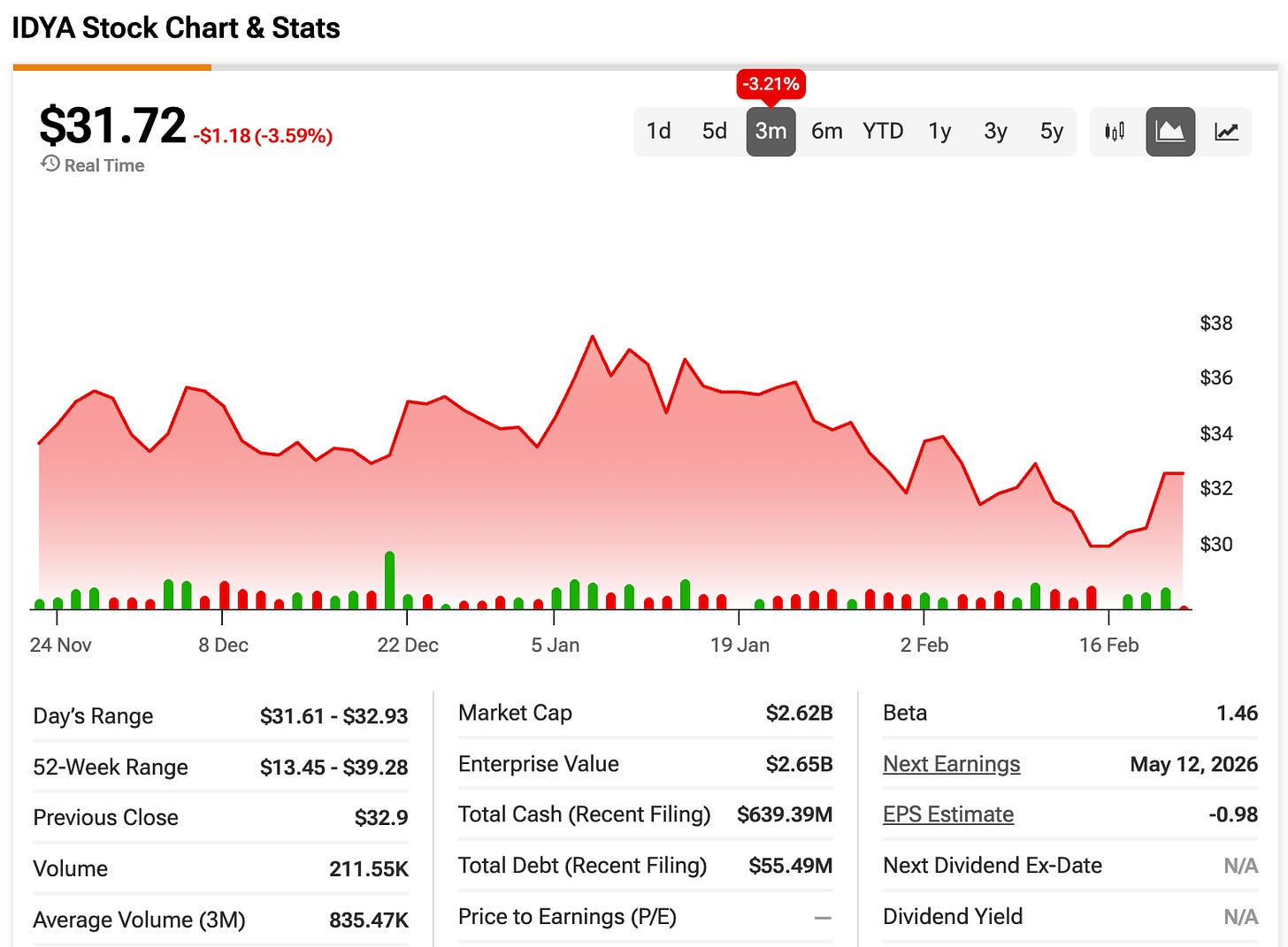

Hedge funds have been buying into the catalyst.

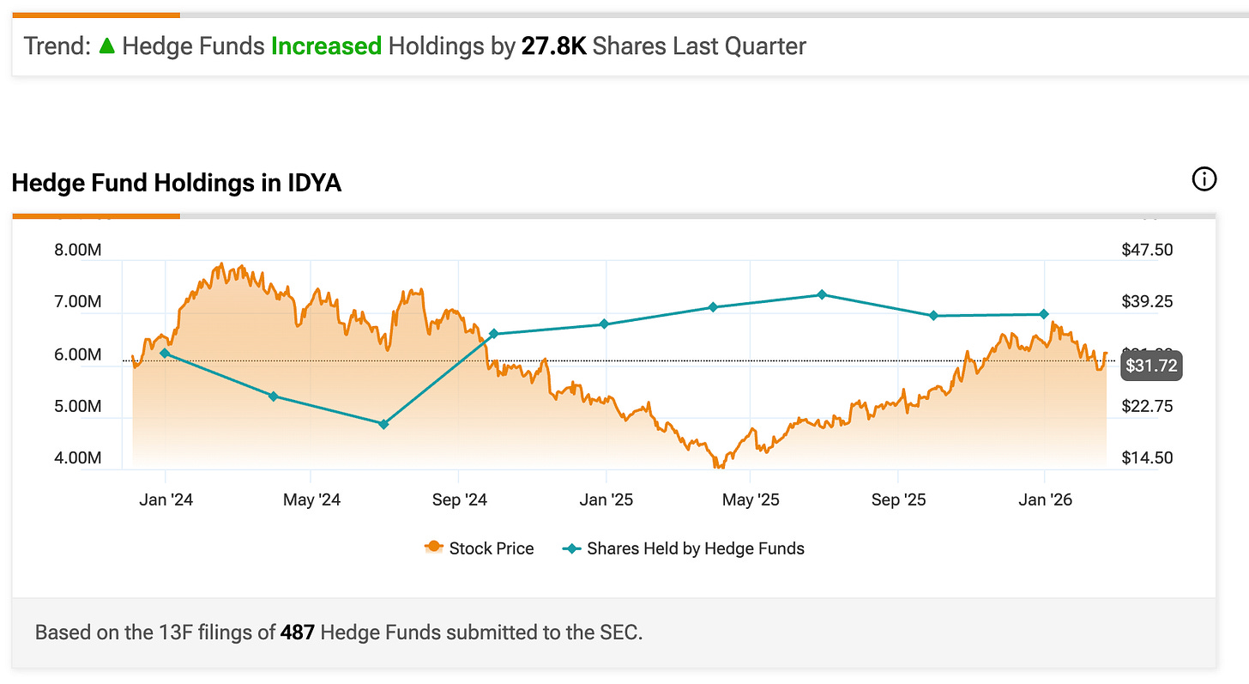

HF positions increasing.

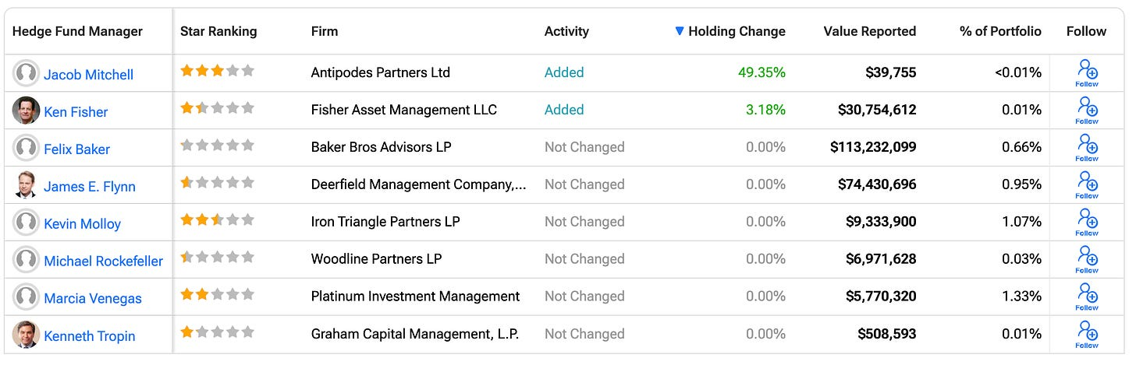

WHAT THEY ARE SAYING ON SOCIALS
Ozmosi notes Readout Q126 upcoming

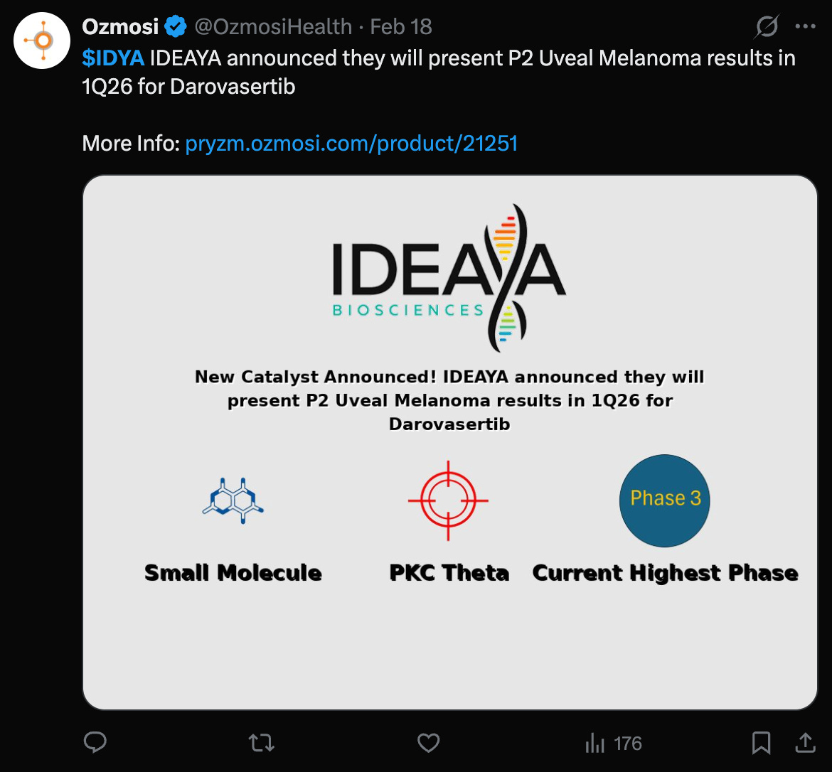

OptionsFlowBoss notes Citi raising target to $65

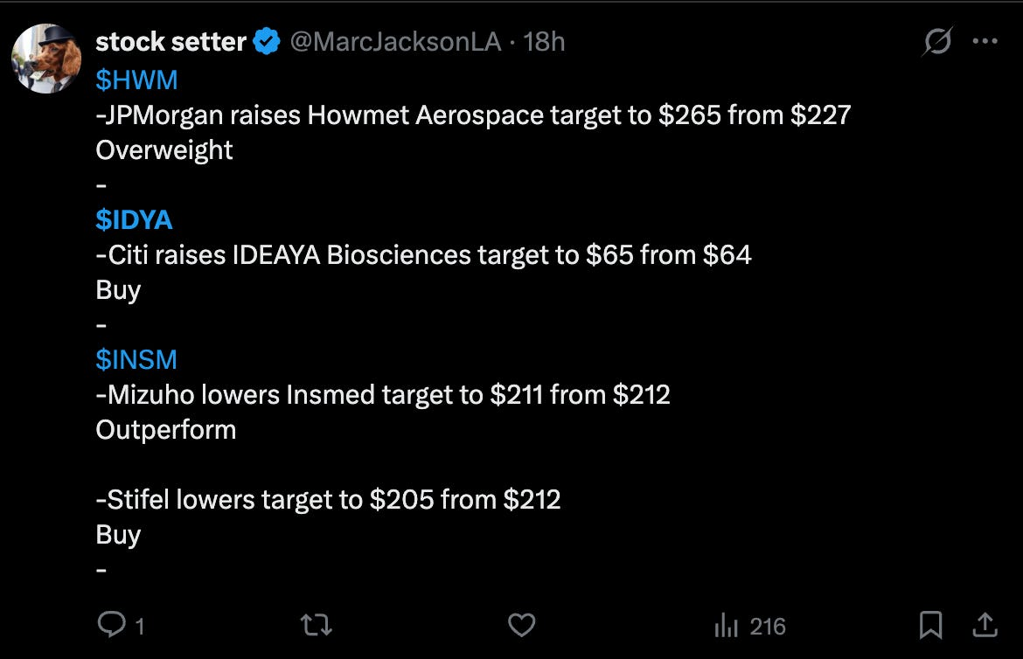

Biotech2k updating NPV to $60.58

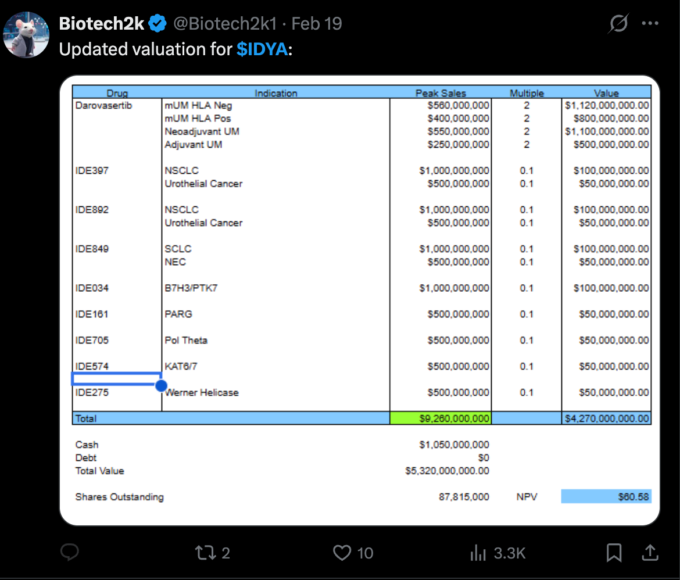

Thank you for reading BowTiedBiotech. Help us grow our community & earn FREE subscription to BowtiedBiotech - sharing is caring!
Share

CONCLUSION
IDYA’s setup into the OptimUM-02 randomized Phase 2/3 PFS readout in 1L HLA-A2-negative metastatic uveal melanoma is simpler than the broader PKC platform debate. The catalyst does not need to re-prove that PKC can be inhibited; it needs to demonstrate that sustained PKC + cMET suppression can meaningfully extend frontline PFS beyond investigator’s choice and validate the single-arm survival narrative.
That requires a clean, end-to-end chain: statistically persuasive PFS separation, durable curve behavior without late convergence, consistent hazard ratio stability across baseline risk strata, and safety that preserves full-dose combination exposure. The market will care far less about the p-value than about hazard ratio magnitude, absolute median delta, KM durability, and whether dose intensity holds without hepatic or cardiovascular creep.
For IDYA, success means OptimUM-02 clearly validating PKC inhibition as a frontline backbone in metastatic UM. A durable and clinically meaningful win would de-risk accelerated approval, expand confidence in the neoadjuvant and adjuvant strategy, and mechanically lift franchise-level probability assumptions.
If the update is mixed, statistically positive but modest in magnitude, with early separation and later curve compression or control-arm attribution debate, investors are likely to fade the durability narrative. In rare oncology, magnitude and robustness matter more than technical success. A marginal win reinforces the view that single-arm data overstated structural benefit.
The best near-term outcome for IDYA is a practice-relevant PFS result: clear and sustained separation versus investigator’s choice, broad consistency, and clean safety that supports uninterrupted BID dosing. That would expand the PKC franchise ceiling and support valuation re-rating into lifecycle expansion.
Anything short of that keeps darovasertib in the “incremental or fragile durability” bucket, with valuation anchored to filing optionality rather than transformative backbone status.
Options are correctly pricing wide tails into the event, reflecting that this catalyst resolves the durability and competitive positioning of PKC + cMET biology, not whether the pathway exists.
Options are pricing wide tails into the 2026 window showing +45% / - 45% potential.

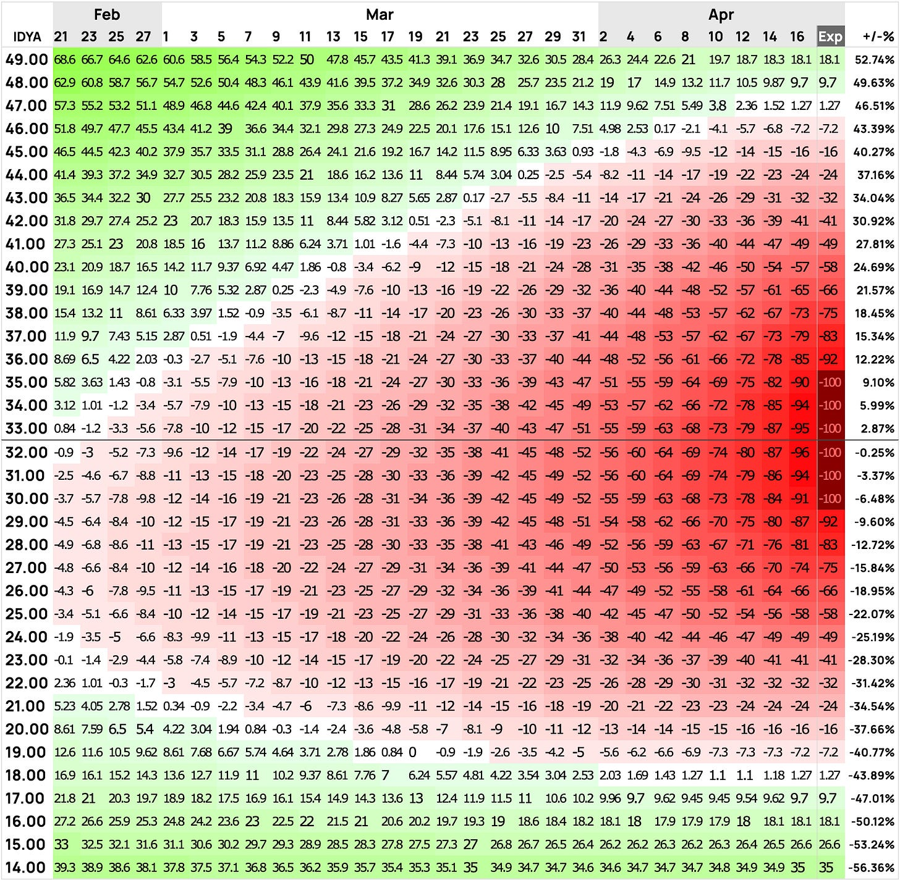

Options are not thin and are clearly structured into April ’26, aligning with the OptimUM-02 PFS catalyst window rather than idle long-dated optionality.
Calls: upside positioning is concentrated higher, not near-the-money drift. Open interest meaningfully builds at $25C (~155 OI), $30C (~42), with a pronounced wall at $35C (~4,665 OI) and additional size at $40C (~1,212). The $35 strike is the dominant call line in this expiry, suggesting traders are targeting a decisive upside breakout into the mid-$30s if the readout clears the durability bar. This is structured upside, not scattered lottery exposure.
Puts: layered but controlled. The $20P (~644 OI), $22.5P (~937), $25P (~410), and notably $30P (~1,033) show real downside hedging. The $30P being the largest put line implies traders are underwriting risk back toward the high-$20s rather than collapse into the teens. Protection is present, but it is structured around drawdown scenarios, not panic.
Read-through: this is a defined event range, not an empty tape. The market appears to be bracketing a move roughly between $25 and $35 into April expiration. A strong OptimUM-02 result would need to punch through the $35 call wall to unlock sustained upside momentum. Disappointment likely gravitates first toward the $30 put cluster, with $22.5–$20 as the deeper support zone if durability optics deteriorate. This setup implies traders expect a real catalyst move, with structured convexity on both sides rather than passive vol decay.

